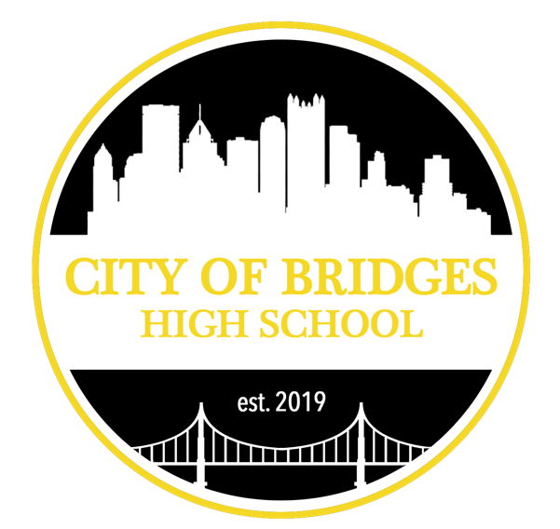
Application for Admission 2022-2023

THANK YOU FOR APPLYING TO CITY OF BRIDGES HIGH SCHOOL.
We believe that students learn best by doing, and that begins with the application process. We’d like you to assemble a thoughtful application packet that helps us learn about you and how you will fit with COBHS.

We need you to submit:

1. A completed application (student information, parent questionnaire, student questionnaire, and essay)
2. One letter of recommendation, from anyone other than a parent who you think knows you best or can speak best to your fit with City of Bridges’ mission
3. A transcript or report card from your current school or a recent homeschool portfolio

by email or mail to info@cityofbridgeshighschool.org or City of Bridges High School 733 North Highland Ave, Pittsburgh PA 15206

If you have any questions, contact Randy Bartlett at (412) 651-5902 or email info@cityofbrigeshighschool.org.

Nondiscrimination Policy
City of Bridges admits students of any race, color, religion, gender, gender identity, disability, sexual orientation, or national and ethnic origin to all the rights, privileges, programs, and activities generally accorded or made available to students at the school. This public benefit corporation does not discriminate on the basis of race, color, religion, gender, gender identity, disability, sexual orientation, or national and ethnic origin in administration of its educational policies, admissions policies, scholarship and loan programs, and athletic and other school-administered programs, employment policies, and election of officers.

Student Information:
Name:

What do you prefer to be called:

Date of Birth:

Current or most recent school (if applicable):

Grade applying for (please circle): 9 10 11 12

Parent/Guardian #1 Information
Name:

Address:

City & State:

Is this address the student’s primary residence Y/N
If no, please explain:

Home Phone:

Cell Phone:

Email:
Parent/Guardian #2 Information
Name:

Address:

City & State:

Is this address the student’s primary residence Y/N
If no, please explain:

Home Phone:

Cell Phone:

Email:

Parent/Guardian Questionnaire:
Please describe the applicant’s academic life.

Please describe their relationships with classmates and teachers.

Please share how you feel the applicant will be a good fit for City of Bridges.

Is there anything else you would like us to know at this time?

Student Questionnaire:

What do you consider to be your strengths?

What do you consider to be areas where you’d like to grow?

Why are you applying to City of Bridges High School?

Please write an essay, no longer than one thousand words, sharing your thoughts on one of the following questions.
Your essay may be handwritten or typed, but it must be neat and legible.
- Describe a problem you've solved or a problem you'd like to solve. It can be an intellectual challenge, a research query, an ethical dilemma—anything that is of personal importance, no matter the scale. Explain its significance to you and what steps you took or could be taken to identify a solution.
- Describe a topic, idea, or concept you find so engaging that it makes you lose all track of time. Why does it captivate you? What or who do you turn to when you want to learn more?
- Some students have a background, identity, interest, or talent that is so meaningful they believe their application would be incomplete without it. If this sounds like you, then please share your story.

